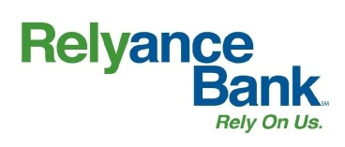

Rate Sheet
Accurate as of 2/18/25. Rates subject to change.

Account Name | Tier | Interest Rate | Annual Percentage Yield
Performance Checking* | $0.01 - $20,000  Premium Level (qualifying) | 1.50% | 1.50%
 | $20,000.01 or more  Premium Level (qualifying) | 0.05% | 0.05%
 | Basic Level (non-qualifying) | 0.01% | 0.01%
*For additional information regarding the Premium Level (qualifying) and Basic Level (non-qualifying), please refer back to the Truth in Savings Disclosure.
Destination Club | Not applicable | 0.07% | 0.07%
Money Market | $0.01 - $49,999.99 | 0.03% | 0.03%
 | $50,000 - $149,999.99 | 0.05% | 0.05%
 | $150,000 - $249,999.99 | 0.08% | 0.08%
 | $250,000 or more | 0.10% | 0.10%
Rely Savings | Not applicable | 0.03% | 0.03%
Relyable Christmas | $0.01 - $2,500 | 3.50% | 3.50%
 | $2,500.01 or more | 0.03% | 0.03%

